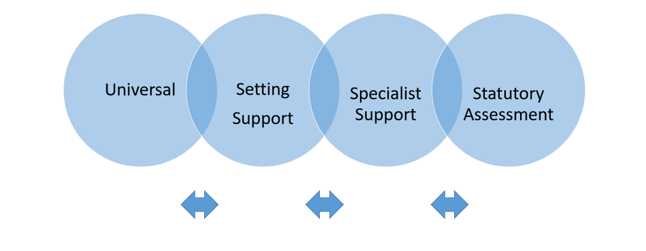

Surrey Support Plan

(Revised August 2022)

Child’s Name:

Date of Birth:

Date plan started:

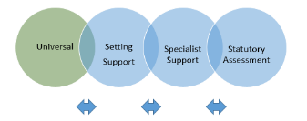
Universal Support
Family and Child Details
Child’s Information
Child’s name |  |  | Setting Name  Contact Person  Address  Telephone/Email
Date of birth
Date child started at setting
Home Address
Telephone/Email

First/Home Language |  |  | Year Group (please tick) |  | -3  NCY |  | -2 NCY |  |  | -1 NCY |  | 0 Reception
Interpreter Required?  (Please state language) |  |  | Are Early Help (level 2 or 3 services) involved?  Is this a child who is looked after?  Child in Need?  Child Protection Plan? |  | Yes/No  Yes/No  Yes/No  Yes/No
Ethnic Origin
Religion
GP name and address (& NHS Number if known)
 |  |  | Is child in receipt of Disability Living Allowance (DLA)?
Parent/carer name/s with parental responsibility |  |  | Parent/ Carer signature

Universal Support One Page Profile for (insert child’s name)
How best to support and communicate with me:
Describe the support the child might need from others to stay safe and healthy. Prompts on the guidance document may help with completion of this section

What people like about me and what I like about myself:

Photo
(Include a photo of child to personalise the plan)

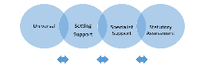Progress Tracker for (insert child’s name)
What is important to me:
Record what really matters to the child. Prompts on the guidance document may help with completion of this section

Date of birth |  | Admission date |  | Date of progress check at age two
KEY:
Colour
Date of assessment
Age (months)
Completing the tracker below:
- Only colour in the whole rectangle for an age band (i.e. all four quarters) if the child consistently demonstrates secure knowledge, skills and understanding in that area.
- If the child is emerging and still requires support to consolidate learning, then you need to make a judgement by colouring 1,2 or 3 of the smaller rectangles within an age-band to reflect their level of skill and development.
- Please refer to the OBSERVATION CHECKPOINTS within Development Matters, to help you make a judgement on the child’s development.
- Your knowledge of child development and the observation checkpoints will help you notice whether a child is at risk of falling behind in their development.
Area of Learning and Development | - year  (0-12mths) |  |  |  | 1-2 years  (12-24mths) |  |  |  | 2-3 years  (24-36mths) |  |  |  | 3-4 years  (36-48mths) |  |  |  |  | 4-5 years  (48-60mths)
Personal, Social, and Emotional Development

Communication and Language Development

Physical Development

PLEASE NOTE: If the child’s tracker indicates that their progress is less than expected, additional assessment tools, such as those below, will help you assess and monitor a child’s progress more closely. Please add a summary of any assessment outcomes to the ‘Summary of Strengths and Needs’ on the next page.
- Teaching Talking Early Years profile
- An Early Language Monitoring tool
- Templates from the Promoting Positive Behaviour Pack (including Positive Behaviour Support Plan).

Summary of Strengths and Needs:
To be updated as the child’s needs change or relevant information is received. Each entry MUST be clearly dated and a different coloured ink used to show each update.

What are the child’s strengths?

Summary of child’s needs:

What level of support is being provided? Please indicate the level of support by adding the date that this level was started or reviewed:

 | Universal | Setting Support | Specialist support | Statutory Assessment
Communication and Interaction
Cognition and Learning
Social, Emotional and Mental Health Needs
Physical and Sensory Needs including Hearing Impairment, Visual Impairment and Multi-Sensory Impairment

What have you put in place to support the child?

What do you plan to do/try next?

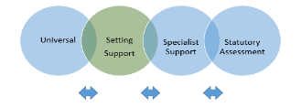
Setting Support: If little or no progress is being made at Setting Support, refer to health, education or other professionals. List the referrals made below:

Name of agency referred to: Date of referral:
Referred by: Setting, GP, Health Visitor, Paediatrician, Therapist (please highlight) One Stop reference number if applicable:
Name of agency referred to: Date of referral:
Referred by: Setting, GP, Health Visitor, Paediatrician, Therapist (please highlight) One Stop reference number if applicable:
Name of agency referred to: Date of referral:
Referred by: Setting, GP, Health Visitor, Paediatrician, Therapist (please highlight) One Stop reference number if applicable:
Name of agency referred to: Date of referral:
Referred by: Setting, GP, Health Visitor, Paediatrician, Therapist (please highlight) One Stop reference number if applicable:

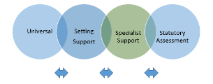
Specialist Support: At Specialist Support, other professionals will be working with the child and family. List the professionals’ details who are involved with the child:

Agency/Professional | Professional’s Name | Contact details | Report received (date)
Specialist Early Education Service (Highlight whether for Portage/LEAP/PPP)
Early Years SEND Team

Supporting Targeted Education and Play Skills (STEPS)
Early Support

Physical & Sensory Support

Educational Psychology (Analysis of Additional Needs Tool - AANT)
Speech & Language Therapy
(SLT)
Occupational Therapy
(OT)
Physiotherapy

Audiology

Paediatrician

Early Help/Family Support Worker/ Social Care

Other:

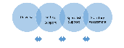
Outcomes and Targets:
Please highlight the relevant level of support: Setting Support / Specialist Support / EHCP
Start date: _________ Cycle___1_____
Outcome | Steps in place to support the outcome | Review date | Progress Review. Highlight if a target has been achieved/partially achieved/not achieved?  Bullet point what has gone well and barriers to further progress
 | SMART Target/s:  Other actions and strategies: |  | Achieved/partially achieved/not achieved  Parents comments:
Outcome | Steps in place to support the outcome | Review date | Progress Review. Highlight if a target has been achieved/partially achieved/not achieved?  Bullet point what has gone well and barriers to further progress
 | SMART Target/s:  Other actions and strategies: |  | Achieved/partially achieved/not achieved  Parents comments:
Outcome | Steps in place to support the outcome | Review date | Progress Review Highlight if a target has been achieved/partially achieved/not achieved?  Bullet point what has gone well and barriers to further progress
 | SMART Target/s:  Other actions and strategies: |  | Achieved/partially achieved/not achieved  Parents comments:

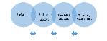
Outcomes and Targets:
Please highlight the relevant level of support: Setting Support / Specialist Support / EHCP
Start date: _______ Cycle____2____
Outcome | Steps in place to support the outcome | Review date | Progress Review. Highlight if a target has been achieved/partially achieved/not achieved?  Bullet point what has gone well and barriers to further progress?
 | SMART Target/s  Other actions and strategies: |  | Achieved/partially achieved/not achieved  Parents comments:
Outcome | Steps in place to support the outcome | Review date | Progress Review. Highlight if a target has been achieved/partially achieved/not achieved?  Bullet point what has gone well and barriers to further progress?
 | SMART Target/s  Other actions and strategies: |  | Achieved/partially achieved/not achieved  Parents comments:
Outcome | Steps in place to support the outcome | Review date | Progress Review Highlight if a target has been achieved/partially achieved/not achieved?  Bullet point what has gone well and barriers to further progress?
 | SMART Target/s  Other actions and strategies: |  | Achieved/partially achieved/not achieved  Parents comments:

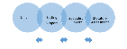
Outcomes and Targets:
Please highlight the relevant level of support: Setting Support / Specialist Support / EHCP
Start date: _______ Cycle____3____
Outcome | Steps in place to support the outcome | Review date | Progress Review. Highlight if a target has been achieved/partially achieved/not achieved?  Bullet point what has gone well and barriers to further progress?
 | SMART Target/s  Other actions and strategies: |  | Achieved/partially achieved/not achieved  Parents comments:
Outcome | Steps in place to support the outcome | Review date | Progress Review. Highlight if a target has been achieved/partially achieved/not achieved?  Bullet point what has gone well and barriers to further progress?
 | SMART Target/s  Other actions and strategies: |  | Achieved/partially achieved/not achieved  Parents comments:
Outcome | Steps in place to support the outcome | Review date | Progress Review. Highlight if a target has been achieved/partially achieved/not achieved?  Bullet point what has gone well and barriers to further progress?
 | SMART Target/s  Other actions and strategies: |  | Achieved/partially achieved/not achieved  Parents comments:
PLEASE NOTE: further Outcomes and Targets tables may be copied and pasted here if there are more than 3 cycles of assess/plan/do/review

Early Intervention Funding Date of Application:
An Early Years setting may request funding to enhance the current adult ratio, to purchase specific resources (recommended by another professional), to pay for relevant training for staff or to fund specific interventions.
Please detail what you are applying for below and describe how it will be used to support the child.
Once completed, submit the Surrey Support Plan with an Early Intervention Funding application form to eypanel@surreycc.gov.uk.
NB: Please only complete the relevant boxes for the funding you are requesting.
ENHANCED RATIO:  Describe the support that will be given by an adult through an enhanced adult ratio | RESOURCES/EQUIPMENT:  Provide details of the resources or equipment, including the cost, supplier and which professional recommended this.  Describe how the resources will support the child | TRAINING:  Provide details of any staff training identified to support the child, including cost and the provider.  Describe how it will support the child. | INTERVENTIONS:  Provide details of specific funded interventions identified by your SEND Advisor to support the child (eg, AANT, REMA, STEPS etc).  Describe how it will support the child

Review of Early Intervention Funding Review Date:
What level of EIF was awarded?  Describe how the enhanced adult/child ratio has supported the child: | What resources were funded?  Describe how these have supported the child: | What training was funded? When was this completed?  Describe how this training has supported the child: | What interventions were funded? When did this happen?  Describe how the interventions have supported the child:

Early Intervention Funding to Support Transitions Date of application:
(Transition funding can be requested to support a child moving into your setting, to another setting or into school)
Describe the support that will be given by an adult (enhanced ratio) to support transition.  Provide costings (eg, hourly rate, number of hours needed etc.) | Provide details of the resources or equipment that will support the child’s transition.  Include the cost, supplier, who recommended the purchase and why. | Provide details of any training identified to support the child’s transition, including cost and the provider.  Describe how it will support the child. | Provide details of specific interventions identified to support the child’s transition, including cost and the provider.  Describe how it will support the child
Total £ | Total £ | Total £ | Total £

Total Cost | £

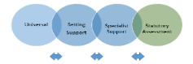
Person-centred Summary for Statutory Assessment:
My History (to include family situation, who is at home, play, health, schooling, independence, friendships, education and future plans).
This section MUST be completed when applying for a Statutory Assessment

[Firstname’s] history – pregnancy and early days, home, play, health, early years care and education, friends and relationships.

Family’s situation -This could be ‘as above’ if no more information to add, or may include information about who is at home, family/siblings etc

How has the family been supported and by whom? (for example, Early Support Service, Family Centre, Family Support Worker, CHES, Social Worker).

Family and child’s views and aspirations for the future, including education

How [Firstname] and his/her family have taken part in this plan
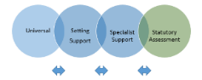
Statutory Assessment - Summary of Strengths and Needs
The summary MUST be completed when applying for a Statutory Assessment

- Has the setting been awarded Early Intervention Funding for this child? Yes/No

- Has an Early Years Inclusion Pathway Planning (EYIPP) Meeting been held? Yes/No

The Summary should be completed by the Early Years Provider. Please consult with parents.

Person Centred Summary
- Communication and Interaction
Please refer to the prompt questions in the Guidance document, the Graduated Response Profile of Need and any professional reports, to help identify the child’s strengths and additional needs. Please include any health needs and/or diagnosis.
Describe my strengths and achievements:

Describe my identified needs relating to Communication and interaction:

- Cognition and Learning:
Please refer to the prompt questions in the Guidance document, the Graduated Response Profile of Need and any professional reports, to help identify the child’s strengths and additional needs. Please include any health needs and/or diagnosis.
Describe my strengths and achievements:

Describe my identified needs relating to Cognition and Learning:

- Social, Emotional and Mental Health:
Please refer to the prompt questions in the Guidance document, the Graduated Response Profile of Need and any professional reports, to help identify the child’s strengths and additional needs. Please include any health needs and/or diagnosis.
Describe my strengths and achievements:

Describe my identified needs relating to Social, Emotional and Mental Health:

- Sensory and Physical (including visual impairment, hearing impairment and multi-sensory impairment):
Please refer to the prompt questions in the Guidance document, the Graduated Response Profile of Need and any professional reports, to help identify the child’s strengths and additional needs. Please include any health needs and/or diagnosis.
Describe my strengths and achievements:

Describe my identified needs relating to Sensory and Physical:

