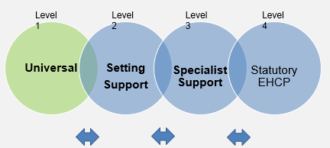
Universal
One Page Profile for (insert child’s name) Date of birth:

How best to support me
Describe the support a person might need from others to stay safe and healthy. The following prompts may help.
Environment: room arrangements, adaptations
Equipment and resources
Mobility, medication, diagnosis and how best to support?
What are the routines that support me? (mealtimes, sleeping etc.)
Intimate care routines
How do people support me?
Are there any dangers to consider?
What are my communication needs?
Medication

Photo (Optional)

What people like about me and what I like about myself [Positives]
What do family and friends say about you?
What do they love and admire about you? (Positive
comments only)

What is important to me?
Record what really matters to someone. The following question prompts may help.
Who are the people I live with?
Who is important to me (friends, extended family other carers, pets) and why?
How do I spend my day?
What do you usually do?
What do you always do?
3 things that make a good day and 3 things that make a bad day. (Summarise what is important about the early years provision, home and wider community/environment?)
What makes me feel better when I am stressed?
Possessions: What would I never leave home without?

