General spontaneous observations are a purposeful part of everyday practice and these may initially alert you to a delay in a particular area. There are a number of observation tools that are very useful in making assessments to ascertain if a child can continue to be supported at Universal level (within best EYFS practice), or requires more targeted interventions at Setting Support level.

In this leaflet we will look at:

  - the developmental tracker
  - a narrative observation
  - a tracking observation
  - a frequency observation
  - the early language audit tool
  - the teaching talking assessment tool (Ann Locke)
  - ABCC

- Developmental Tracker

What is a development tracker?
It is a visual summary of formative assessments such as observations, information from parents or samples of a child’s work that provide evidence to help make a best fit judgement on the age/stage band the child is working in. The developmental tracker on the Surrey Local Offer focuses on the prime areas of learning. These are important because they lay the foundation of learning in all other specific areas. The focus on the prime areas enables early identification of any concerns around development.

Why is it useful?
Using a developmental tracker can help identify whether a child is showing typical development for their age, may be at risk of delay or is ahead for their age. It provides a visual representation of a child’s progress over time. It enables development to be monitored and identifies which prime areas need further support.

How do I use it?
The observer records a strong black line to show a starting point on the tracker (baseline). The tracker is completed termly with progress recorded through the use of coloured boxes on the tracker. It details a ‘best fit judgement’ within the EYFS age band the child is working in.

The tracker has three descriptors, practitioners should consider whether a child is ‘emerging’ within the age/stage band, ‘developing’, or ‘secure’. The descriptors refer to:
- Emerging - Children are able to independently demonstrate the knowledge, skills and understanding to reflect some of the examples in the developmental age/stage band.
- Developing - Children are able to independently demonstrate the knowledge, skills and understanding to reflect the large majority of the examples in the previous age/stage band, and most of the examples in the considered developmental age/stage band.
- Secure - Children are able to independently demonstrate the knowledge, skills and understanding to reflect all the examples in the previous band, the majority of the considered band and are moving to the next developmental age/stage band.

- Narrative Observation

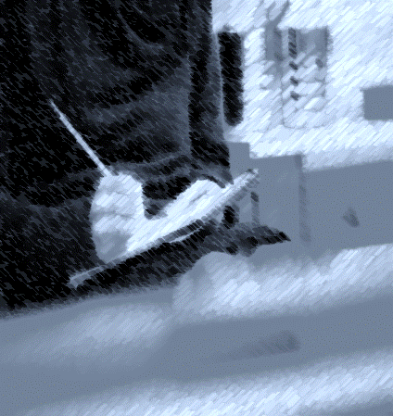
What is a narrative observation? A narrative observation is an extended written account of what the child is doing including an exact record of the language used by the child, a description of their play and their involvement with others. It needs “adult time” to complete and is normally about 20-30 minutes of continually watching and writing everything the child says and does.

Why is it useful?
The observation requires the observer to detail everything they see and hear the child do to help understand the behaviours of the child and the context in which it took place. It builds a picture of the child’s interests and overall development.

How do I use it?
Plan to capture the child’s responses to a range of activities and routines within the session. It is useful to have time to evaluate the observation as you can note anything that is unusual or exceptional about the child. For the purpose of early identification, focus on evaluating what is working well and then what is not working well within the prime areas of learning. Consideration of next steps to supporting the child and reference to the SEND Early Years Graduated Response document will help to assess if the support needed is required at a universal level or setting or specialist support.

- Tracking Observation

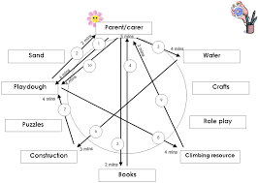
What is a tracking observation?
A tracking observation captures the movements of the child and the length of time they spend at each activity or area of learning.

Why is it useful?
This type of observation helps to identify a child’s current interests and the duration that different activities hold the child’s attention. It is useful to ascertain if a child always goes to the same activity on arrival, what areas of the learning environment the child does or does not access, and the length of time they remain focused on any one activity.

How do I use it?
To record a tracking observation it is useful to have a floor plan of the setting including the outdoors. The practitioner observes for an hour or more and notes on the floor plan where the child goes and how long they stay in a particular area. The child’s movement is recorded using a series of lines and the time spent at each activity is noted. Analysis of the time spent at an activity or area of learning will help identify if the child doesn’t move or access much of the learning environment or seems to flit from area to area very quickly.

- Frequency Observation

What is a frequency observation?
A frequency observation involves the recording of behaviours or use of activities as they happen throughout the day or session.
Why is it useful?
Frequency observations are useful to identify when, where and how frequently specific behaviours occur and/or how often an activity is used. When used over time, it can help to establish if there is a pattern of behaviour or to identify high or low interest activities. It can also be used as a baseline to monitor progress or the impact of any interventions.
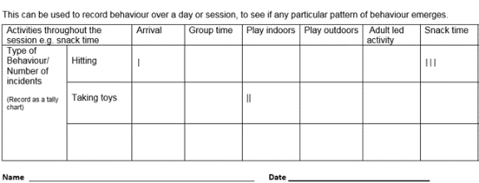
How do I use it?
A frequency observation chart can be adapted to show the routine of a typical day or session, periods of time, or activities available. When a specific behaviour is seen, a tick or tally is recorded each time it occurs. When used each day for a period of time, this can be used to identify if there are specific times of the day or week, activities or routines where the behaviour is more or less frequent. You can then use this information to plan interventions to reduce or encourage an alternative behaviour. An example of an ‘Incidents Chart’ can be found in the Appendices section of the ‘Promoting Positive Behaviour in Early Years Settings’ pack under Resources (Universal and Setting Support).

- The Early Language Monitoring Tool

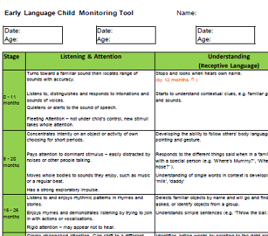
What is the early language monitoring tool?
The Early Language Monitoring Tool enables you to review an individual child's progress in each aspect of Communication and Language in Listening and Attention, Understanding, Talking and Social Communication.

Why is it useful?
This tool has helpful red flags against some statements in each aspect, if a child hasn’t achieved the statement at this age and stage they could be at risk of delay. Close monitoring with some further assessments and intervention to support this area would be required. There is also a grid on the back of the audit, which shows the development of speech sounds in ages and stages.

How do I use it?
This is a summative assessment tool and should be completed from on-going observations of the child. Within each band, a judgement will be made in two levels – either ‘Emerging’ when a child shows some development at that level, or ‘Secure’ when most of the statements reflect the child’s current development.

In considering whether a child is at risk of delay, as expected, or ahead in each strand of communication and language, it is necessary to consider the child’s actual age in months in relation to the overlapping age bands. If a child is within two months of the end of the age band and development is not yet within the band or is judged to be ‘Emerging’, then a judgement of ‘risk of delay’ would be appropriate.

5 Talking Teaching Profiles (commonly known as an Ann Locke)

What is the Teaching Talking Profiles?
The Teaching Talking profiles are a set of statements that focus on a range of developmental criteria that includes expressive language, listening and attention, self-help skills, hand/eye co-ordination and physical skills to create a holistic assessment.
Why is it useful?
It provides an in-depth profile of the child’s current development and can be linked with the EYFS Prime Areas. It should be regularly updated to review the impact of interventions and to document progress the child may be making.
How do I use it?
Profiles are available in age ranges 0-1 years, 1-2 years and 2-5 years. To complete a Teaching Talking profile, choose one colour for completing the first assessment. The assessment must be completed over the course of a week. If you do not see certain behaviours, plan for these activities to be provided for the child during the course of the assessment so that a judgement can be made.
Consult with colleagues so you get an accurate picture of the child you are assessing. Parents could also be asked to complete a separate assessment to get an overview of the child’s development in the home environment.

Behaviours that are demonstrated regularly and spontaneously should be identified by colouring the square completely, (no square should be completely coloured in until the behaviour is fully established).
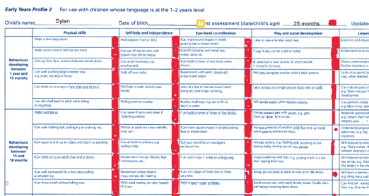
Behaviours that are developing but are not consistent or used spontaneously should be identified by partially colouring the square.
Behaviours that show little or no development should be identified by marking a dot in the first quarter of the square.
Choose a different colour for the next assessment (remember to date it). Reassessment should be at least 3 months from the initial date.

Interpreting the results
To interpret the results of the assessment, identify which bands or developmental areas have most of the squares fully coloured in. If the developmental level matches the child’s age, this would indicate that the child is working within age expected levels.
Any areas which have only some of the squares fully or partially coloured, indicates that the child will need opportunities, time and support to develop and consolidate skills at this level.
Any area which has very little colouring or numerous dots is likely to be beyond the child’s present level of development. The child will need an increased level of support and planned interventions to promote progress.
The profiles are available at:
https://www.gl-assessment.co.uk/products/teaching-talking

  - ABCC Charts

What is an ABCC Chart?
An ABCC Chart is an observation tool which allows you to document reoccurring undesirable events/behaviours that happen within the child’s environment.

Why is it useful?
The ABCC Chart is useful to help analyse and understand what a child is communicating through their behaviours e.g. throwing a cup to communicate their need for a drink or taking another child’s toy as an invitation to play. The chart can help the adult to support the child with finding a more socially acceptable way of communicating an unmet need. This is usually supported using a positive behaviour plan.

How do I use it?
This chart should be completed over a week or two before being able to find the communication behind the behaviours. The chart includes:
A- Antecedent - (Where? When? Who with?)
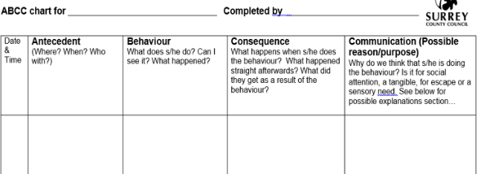
B- Behaviour - (What does s/he do? Can I see it? What happened?)
C- Consequences - (How did the adult react? What happens when s/he does the behaviour? What happened straight afterwards? What did they get as a result of the behaviour?)
C- Communication - (What is the child communicating? What are the possible reasons/purpose of the behaviour?)

Once completed, you may identify changes that you can make to your environment, routines or practice. If a child requires individual support, a positive behaviour plan could be implemented to help them use socially acceptable ways to communicate their unmet needs. For more information, please refer to the Promoting Positive Behaviour Pack.

Summary

Where initial observations and assessment tools indicate delay or concern regarding a child’s development, the practitioner should contact the Graduated Response Early Years Team (GREYT) to request support. This can be done by completing a request for support form and emailing it to the relevant quadrant. The Early Years SEND Advisor will contact you to gather further details and explore the information further.

The aim of sharing observations and assessments is to enable an appropriate plan of support to be implemented at the earliest opportunity. Early identification can still be achieved using the methods in this leaflet and through working together.

